Online Payments, Cash Pay, Opt-in Credit Reporting and New Mobile App
7/21/21
To Our Valued Residents:

[Community Name] is moving to 100% online payments and in the future all communications will be electronic as well. Your community manager is available to answer any questions you may have and will be able to assist you in setting things up and making sure that this process goes smoothly. The same late payment and late fee rules will remain in place during this transition. Many of you are already making payments online but for those that do not, it will take a month or two to get used to and we are here to help.

So, with that said, please note: EFFECTIVE SEPTEMBER 1ST 2021, CASH, MONEY ORDERS AND/OR CHECKS WILL NO LONGER BE ACCEPTED AT THE COMMUNITY. ALL PAYMENTS MUST BE MADE THROUGH A DIGITAL PAYMENT METHOD.

WHERE DO I PAY?

- Resident Portal
  - Visit [Community Website] and click on Resident Portal to Log In.

- New Mobile App
  - On your Android or Apple device go to Google Play or the App Store, search and download the rmResident app.

- Cash Pay Location
  - With thousands of locations nationwide, you can conveniently find a Cash Pay location almost anywhere you would buy Money Orders.

Method of Payment | Resident Portal | rmResident App | Cash Pay | Fee to Resident
Cash | -- | -- | $$√$$ | $4.00
ACH Transfer/Bank | $$√$$ | $$√$$ | -- | FREE
Credit Card | $$√$$ | $$√$$ | $$√$$ | 2.95%*
*Charged by our payment processor, Zego.
If you have never made rent payments online, the time is now. Payments can be made from the convenience of your home, office, or mobile device. Online payments are fast, easy and secure.

Thank you for your cooperation with this exciting change as we keep up with the future!

[Community Name]

Resident Portal Access
To create a new account, go to: [Community Website], click “Resident Portal” and sign up at the bottom.
Your account number is: [AccountNumber()]

While logged into Tenant Web Access, click the tabs at the top of the page to:
- View your open charges
- Display your transaction history
- Make a one-time payment or set-up an auto payment
- Sign your lease
- View violations
- Change your password and update personal information

Opt-in Credit Reporting
To sign up for the credit reporting, go to the top right-hand corner and use the drop-down box under your name and select credit reporting. Fill out all information and you are signed up.

PayLease/Zego only reports payments made through Tenant Web Access to the credit bureaus so this feature can only benefit you! This is a free service if you decide you no longer wish to participate you may opt-out at any time. Online payments are processed by PayLease. For questions regarding credit reporting, contact PayLease at (866) 729-5327.

rmResident App
Create online account on Resident Portal Access. Use the same email and password that you set up with the Resident Portal Access.

While logged in you can make your payments and sign up for Opt-in Credit reporting by selecting the settings icon and Credit Reporting button.

Attached are instructions to help you get set up.

Cash Pay
Replace paying rent with money orders and pay rent electronically with cash from one of 25,000 CheckFreePay Locations nationwide. Please see the attached flyer.

Your Cash Pay account number is [CashPayAccountNumber()]

If you have any questions about Tenant Web Access or Cash Pay, please do not hesitate to call.

* The purpose of this email is to promote online payments. Please note that a processing fee may apply to online payments. *

Download the New rmResident App!
We're pleased to announce the new rmResident app which makes it easy to schedule and submit payments, make maintenance requests, stay in contact with us and more!
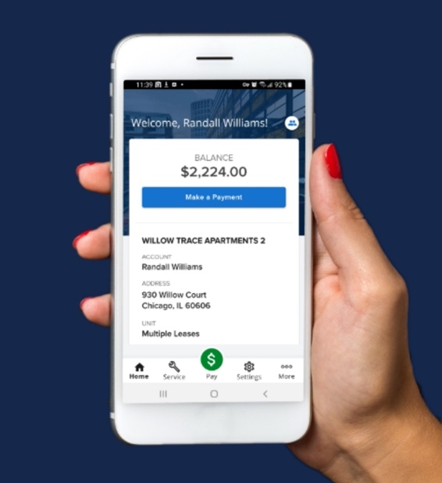
To begin using the app on your mobile device:
  - From Google Play or the App Store, search and download the rmResident app.
  - After you open the app, you will be asked to enter the following:
Company Code: bedg
Community (if applicable): default
  - [if(Length(PortalUserName())>0,"Log in with your TWA account: " & PortalUserName,"Click 'Sign Up' to create an account.")]
We're excited to offer services that deliver continued flexibility and freedom to stay in touch with us from your smart devices.

